Treffen sich zwei ...

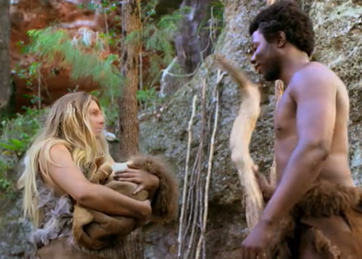Im Film hast du gesehen, dass Neandertaler und Homo sapiens teilweise zur gleichen Zeit am gleichen Ort lebten. Nun stelle dir eine Begegnung vor:

Was hätten sie sich wohl zu sagen? Worüber hätten sie womöglich gesprochen? Was hätte sie aneinander interessieren können? Was hätten sie sich vielleicht gefragt? …?

Schreibe einen Dialog!

Homo sapiens: ____________________________________________________________________________________________________

Neandertaler: _____________________________________________________________________________________________________

Hs: _________________________________________________________________________________________________________________

Nt: _________________________________________________________________________________________________________________

_____________________________________________________________________________________________________________________

_____________________________________________________________________________________________________________________

_____________________________________________________________________________________________________________________

_____________________________________________________________________________________________________________________

_____________________________________________________________________________________________________________________

_____________________________________________________________________________________________________________________

_____________________________________________________________________________________________________________________

_____________________________________________________________________________________________________________________

_____________________________________________________________________________________________________________________

_____________________________________________________________________________________________________________________

_____________________________________________________________________________________________________________________

_____________________________________________________________________________________________________________________

_____________________________________________________________________________________________________________________

_____________________________________________________________________________________________________________________
© SWR

_____________________________________________________________________________________________________________________

_____________________________________________________________________________________________________________________

