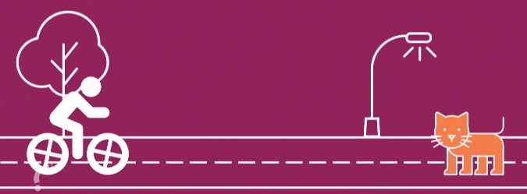
Hindernisse

1. Was kann den Bremsweg verlängern?
platte Reifen
harter Sattel
viel Gepäck
nasse oder glatte Straße
schwache Bremsen

2. Suchsel

Finde elf Wörter zum Thema Verkehr:

F | A | H | R | R | A | D | L | A | B | R | E | M | S | E | N
I | N | U | G | L | D | X | U | P | A | W | O | H | K | Y | S
A | N | H | A | L | T | E | W | E | G | T | Q | A | U | L | E
D | V | U | F | I | O | N | B | I | G | C | A | A | S | V | U
R | E | G | S | T | E | N | R | E | A | K | T | I | O | N | P
O | M | E | T | E | R | Ö | O | R | L | S | T | U | V | E | K
K | R | X | A | B | B | E | B | W | C | H | W | Ü | G | F | I
O | P | I | R | A | F | A | H | R | R | A | D | H | E | L | M
L | A | L | T | Z | C | K | T | P | P | U | P | X | F | Y | A
Ö | B | U | R | S | I | L | L | W | Y | T | R | A | A | L | U
V | S | I | C | H | E | R | Ü | C | H | O | T | T | H | A | S
E | T | J | B | R | Ü | P | X | K | U | R | W | E | R | H | O
N | A | K | I | A | Z | O | R | O | P | P | U | S | Ü | R | Q
N | N | O | K | U | Z | R | A | N | W | I | I | W | M | O | D
X | D | L | A | D | Ä | S | I | M | E | D | J | X | G | N | M

