Quiz & Video
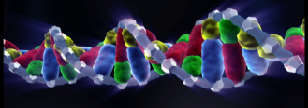


1. Right or wrong?

Prepare some right or wrong questions for your classmates. Use information from worksheet 1–4.

2. Prepare a quiz.

Prepare some quiz questions for your class mates. Use information from task 1-4.

Example:

The 4 bases of the DNA are called:

guanine, thymine, adenine and cytosine

gutanin, thymin,
adennin and Cytosine

paternity test

sugar, phosphor, genetic material and cell

3. Become a star.

Record a short video about one topic of the tasks on worksheets 1-4. Become an investigator, a burglar or a lab assistant – you decide. Be creative
© Colourbox.com, supplier229412

