Determining the Genetic Fingerprint in the Laboratory


4. DNA replication. Match the pictures with the correct texts. Fill in the letters. Then cut out the texts and glue them next to the pictures.


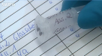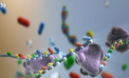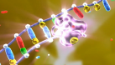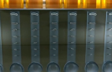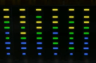
After that, the tools for constructing the ladders are given to the sample: Primers, that define the start of copying and enzymes that turn single strands into double strands.

Crime lab analysis focuses on parts of the DNA whose length differs from person to person.

A process called chromatography is used to divide the segments according to length.

Therefore first of all the building blocks for new DNA ladders are added: sugar, phosphate and the 4 bases.

In the lab the sample is given an identity number. After that the DNA has to be replicated millions of times over.

In the final stage the trace, along with other traces, is portrayed on a colour chart.

After 3 cycles of heating up, separation and duplication 8 copies are created, after 30 cycles, the total is 1 billion.

Different temperatures cause the DNA strands to separate and the primers to dock on. This is where the enzyme polymerase starts to turn each individual strand into a double strand.

A
B
C
E
F
G
H
D
A

© SWR

