The Paternity Test

Today a blood relationship can be checked with a paternity test. The potential father does not even have to be present for it. It is enough to collect the traces he leaves behind without noticing. Nearly each cell of the human body contains all DNA. To compare the genetic information a saliva sample of the mother and one from the potential child is needed.

3a. Collecting evidence for the test.
Tick () the items that are very likely to contain a large number of genetic material of the potential father. In the end add more items, you can think of.

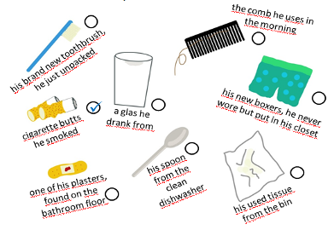

3b. Is he the father or not?
Read the text and have a look at the positive paternity test. Then go through the other paternity tests and find out, whether the child and the man are related.

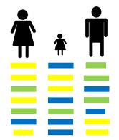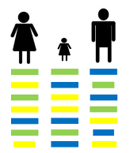In the case of a clear blood relationship, the genetic fingerprint of the child would show that certain whole segments of its genotype are sometimes identical with the mother and sometimes with the father.
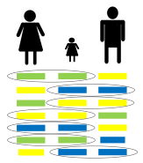

father (  ) father ( ) father ( )

3c. Your own paternity test.
© Tanja Appel
Create your own results of a paternity test. Show it to the class and see if they can find out if the man is the father or not.

