The Genetic Code

2a. How is our genotype constructed?

Match the sentences with the correct numbers in the graphic. Start copying the sentences after that.

a. The cells develop different functions.
This is how e.g. organs, the blood system or body features evolve. Nr. _5_
b. In the end a human being is formed and keeps on growing and developing. Nr. ___
c. The other 23 chromosomes come from one of our father´s sperm cells. Nr. ___
d. When these two meet, the chromosomes combine to a full set of 46 chromosomes. Nr. ___
e. We get 23 chromosomes from our mother, stored in the egg cells. Nr. ___
f. After that, the cell divides. This leads to growth. Nr. ___

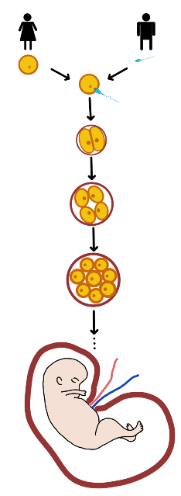
1. ____________________
______________________
______________________
______________________
______________________

2. ____________________
______________________
______________________
______________________
______________________

3. _________________________
___________________________
___________________________
___________________________

4. _________________________
___________________________
___________________________
___________________________

5. ____________________
______________________
______________________
______________________
______________________

6. ____________________
______________________
______________________
______________________
______________________

© Tanja Appel

The Genetic Code

2b. Our DNA / genetic material.
Fill in the gap text about the DNA.
Then use the gap words to label the graphic.

cytosine – sugar – thymine – phosphate – guanine – adenine – DNA

Each of our chromosomes consists of a twisted rope ladder known as DNA. The side pieces are constructed out of ________ and ________________. The rungs are made up of pairs of two bases. Either __________ and ____________ or _____________ and _______________.

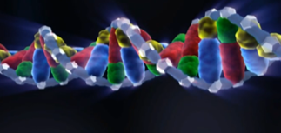

adenine

2c. Genotype portions.
Match the karyograms with the different animals. Also fill in the number of chromosomes each individual has.

A karyogram shows the full set of chromosomes of a living organism. The chromosomes are arranged according to their size. Even when karyograms show a large number of chromosomes, this does not automatically mean they come from a complex creature.

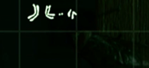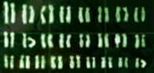
animal: _____________________________________

number of chromosomes: ______________________

animal: _____________________________________

number of chromosomes: ______________________

animal: _____________________________________
© SWR

number of chromosomes: ______________________

