DNA-Evidence


1a. The human cell.
Read the text and label the picture of the cell

If you take a look at a human cell under a microscope you can see different cell organelles. They all lie in a liquid called cell plasma and they all have different functions. The control center of the cell is located in the so-called nucleus. This is also where our DNA or genetic material is stored. It contains information about e.g. our eye colour or the length of our arms and legs. It unmistakably identifies everyone of us. Other cell organelles are for example the mitochondria which are the powerhouses of the cell. The endoplasmic reticulum plays an important role for different metabolic processes. Part of it is covered with ribosomes which are responsible for the construction of proteins.

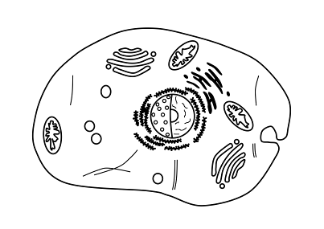

nucleus containing the

the DNA / genetic

material

1b. Leaving traces behind.
Decide whether the following statements are right () or wrong (). Correct wrong statements in the text.

1. Fingerprints work like an identity card for each person, the pattern is unique.
2. Not even identical twins have the same fingerprint patterns.
3. If a criminal removes the physical fingerprints from a crime scene, it guarantees that he or she will not get caught.
© Martina Frietsch
4. Sometimes criminals leave their “biological visiting card” behind, without noticing.
5. There is a genetic defect called “Adermatoglyphia“ that causes a person to have no fingerprints.
6. DNA traces can be helpful to identify the exact age of a person.

