

Energie aus Biomasse – Abschlussdiskussion

Nimm Stellung zu folgender Aussage oder zu folgendem Bild:

a.

„Mit Ökoenergie in die Maiswüste?“

b.
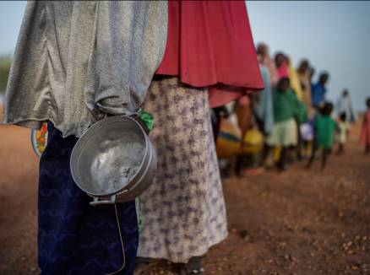

______________________________________________________________________________________

______________________________________________________________________________________

______________________________________________________________________________________

______________________________________________________________________________________

______________________________________________________________________________________
© Shutterstock.com, Stosun
______________________________________________________________________________________

______________________________________________________________________________________

______________________________________________________________________________________

______________________________________________________________________________________

______________________________________________________________________________________

______________________________________________________________________________________

