People in Melbourne (part 2)

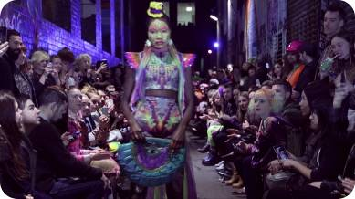1 a. What do you think of Nixi Killick’s fashion? How is her growing up in the bush reflected in her collections? Describe what colours, materials and ideas she uses.

1 b. Go to Nixi Killlick’s website (http://nixikillick.com) and find a collection you like. Imagine you are a reporter at a fashion show. Write a radio report on what you can see, what you like and what you don’t like so very much.

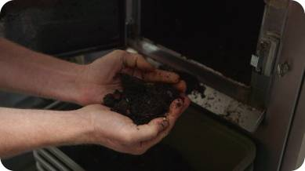2 a. Joost Bakker’s „Greenhouse Restaurant“ in Melbourne is very special regarding his waste management. Make a list of what he does differently.

Joost gets the milk for his restaurant ... He has banned ... from his restaurant. He avoids as much ... as possible.
He produces ... of organic waste a year. His house on the outskirts of Melbourne is special because ... He only uses recycled and recyclable materials like ...

2 b. Describe this photo and explain
what it has to do with Joost’s vision
of sustainability.

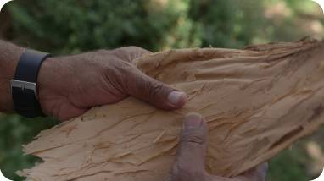
3 a. Mark Olive is an Aboriginal.
Collect information about Australia’s indigenous people and their situation in the Australian society in our day and age.

3 b. Why do you think Mark Olive is such a very famous cook in Australia now?
What ingredients does he use for his meals?

