People in Melbourne (part 1)

1. While watching the film, take notes and then complete this grid about the four inhabitants of Melbourne portrayed in this film.

 | 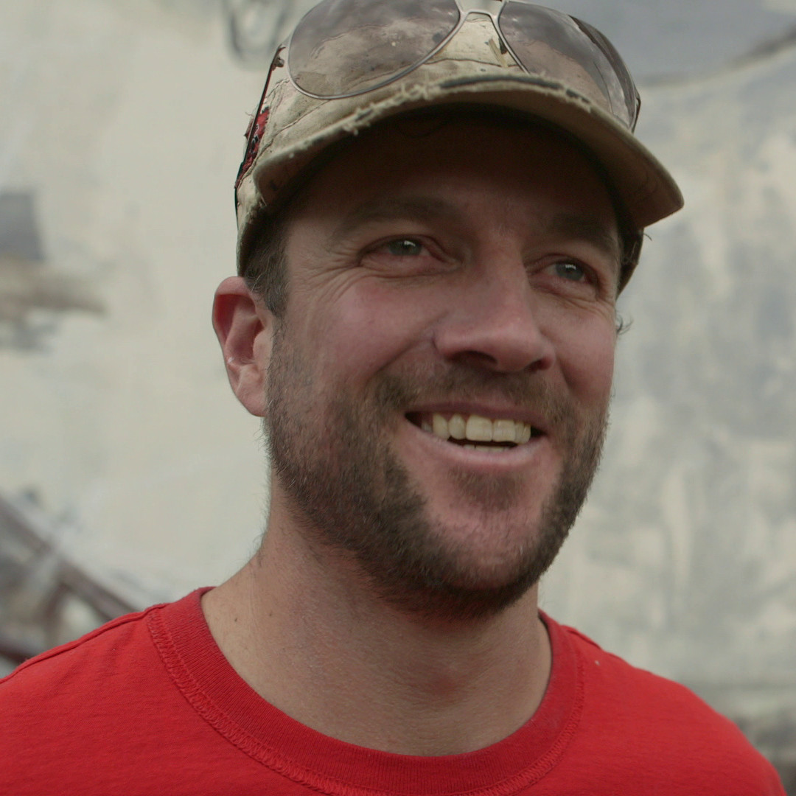  Mike Makatron |   Nixi Killick | 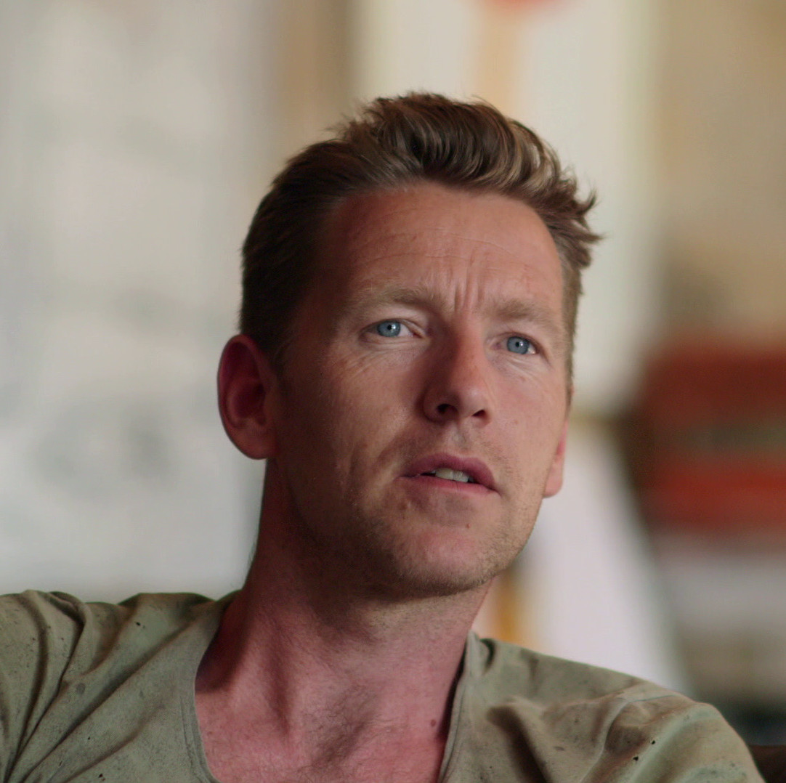  Joost Bakker | 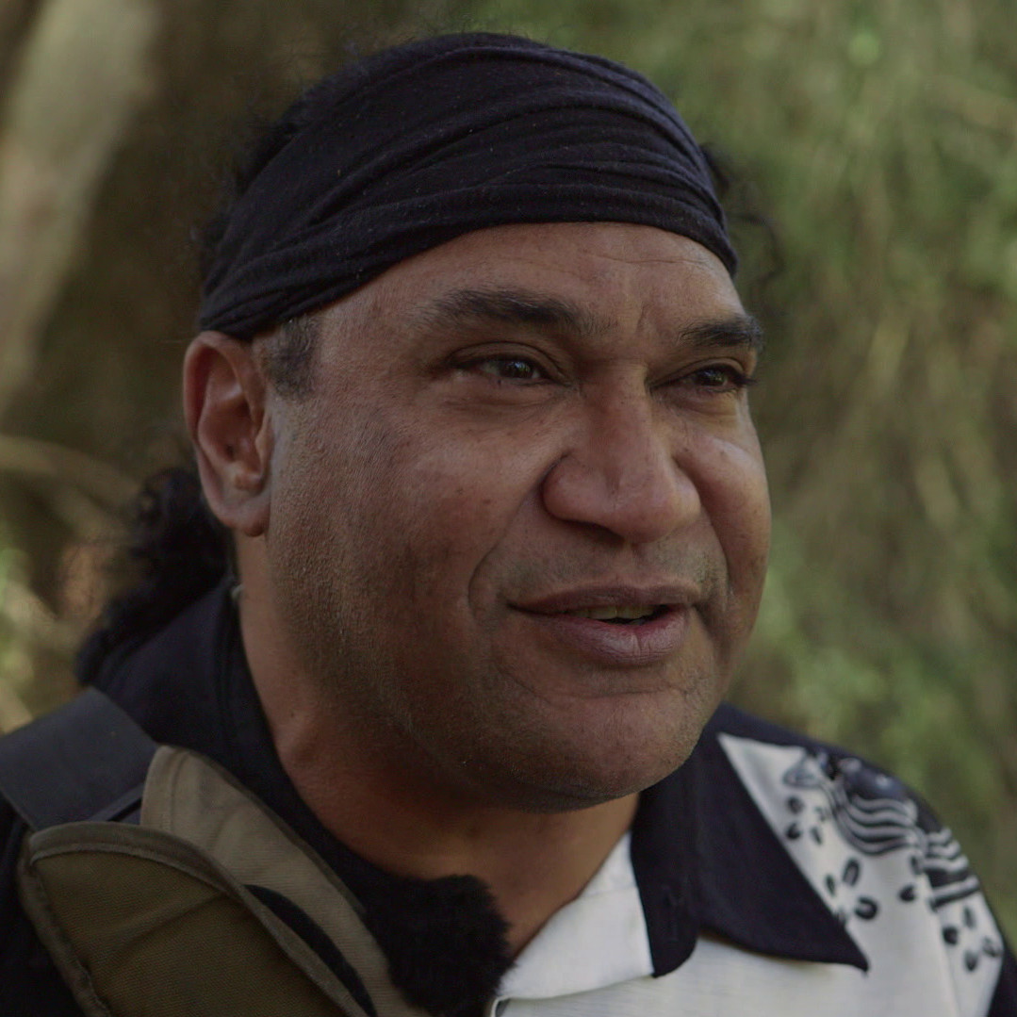  Mark Olive
What are these four people’s jobs?
What is these people’s motivation for their work?

What has been these people’s greatest success so far?

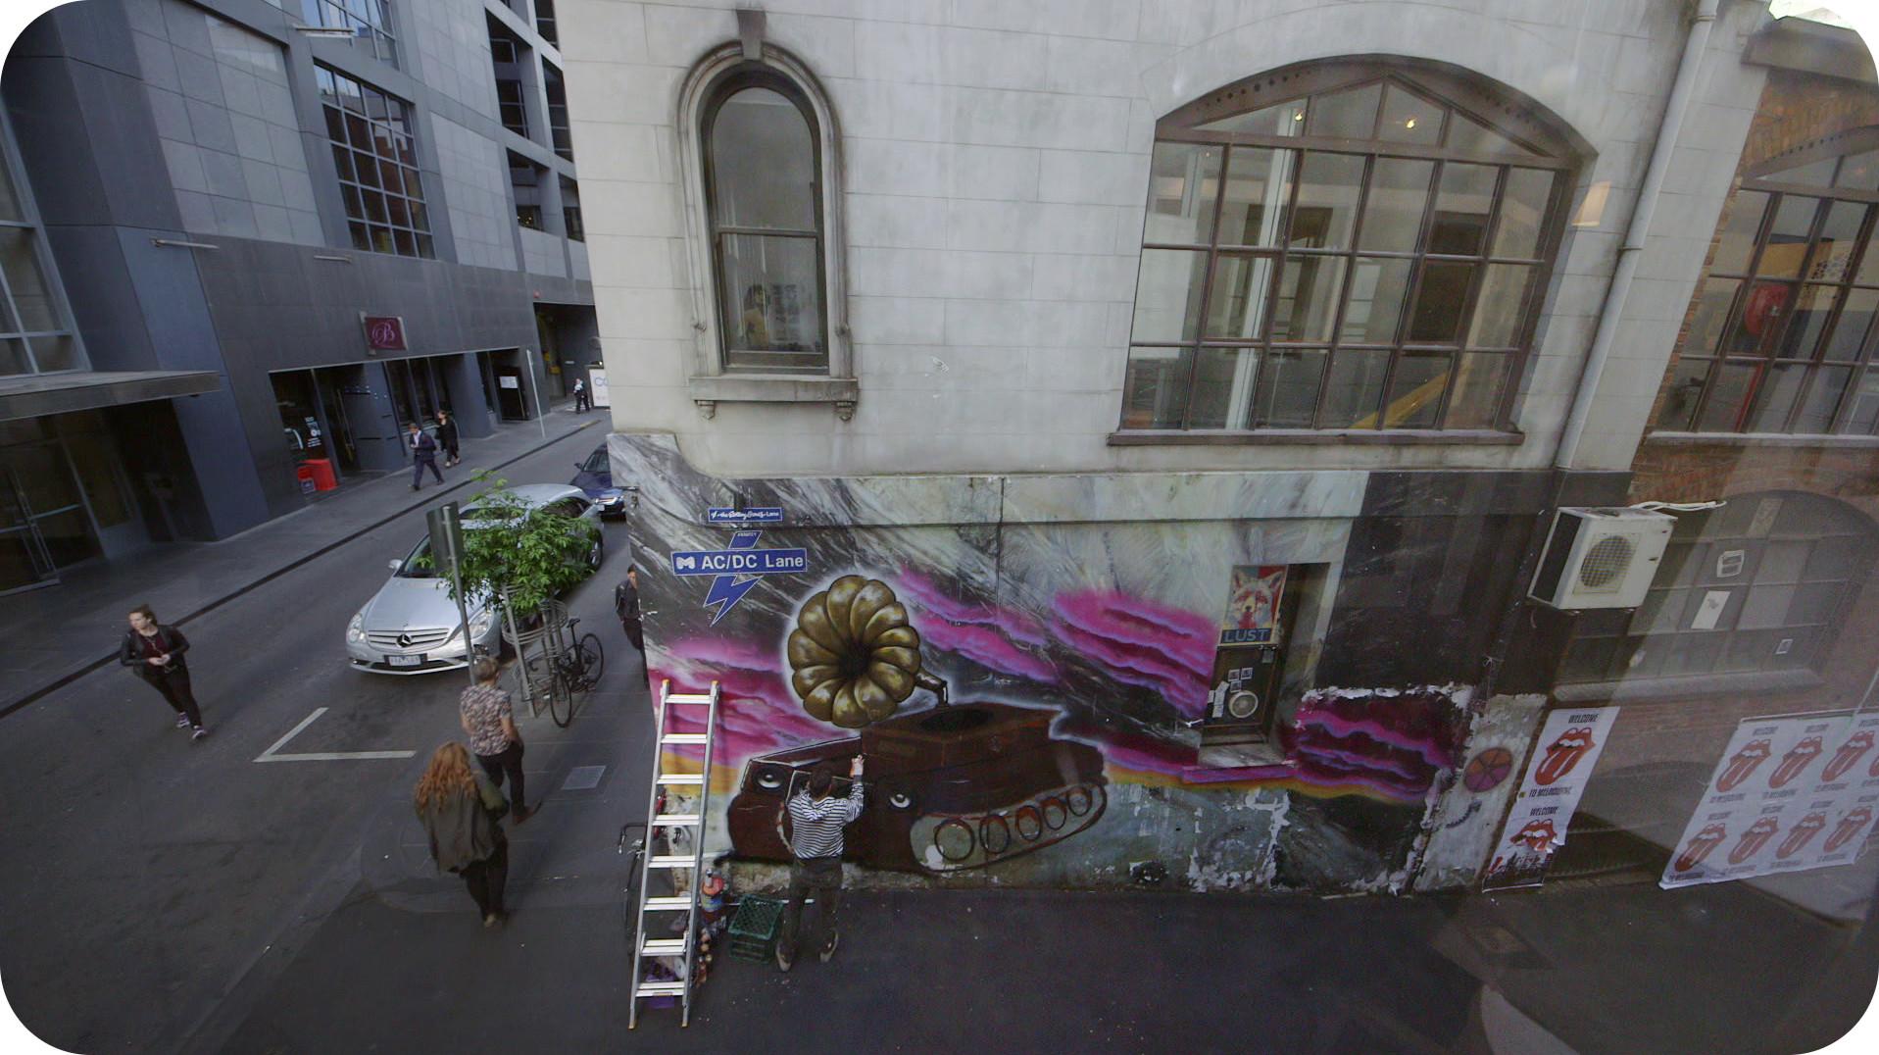2 a. Streetart plays an important role in Melbourne and Mike Makatron is one of the most prominent street artists.

What is the message behind the graffiti he has just finished?

2 b. Can you find streetart in the area where you live?

Go and find examples of streetart that you like and write a report. Illustrate your report with one or two photos of streetart.

Comment on the examples you have chosen.

