Melbourne – Geography

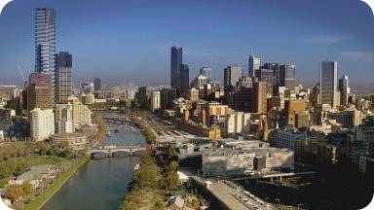1.
Describe this photo of the city of Melbourne. Imagine you are walking along the river.

What would you like to see and where would you like to go?

What would you hear and smell?

2.
Look at the map of Australia and describe where Melbourne is situated.

Find out how far Melbourne is away from Sydney, Perth and Darwin.

Compare to the distance between Hamburg and Berlin.

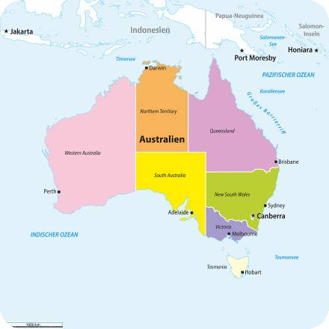

© Fotolia.com, 123mapids

