Scotland: Tides
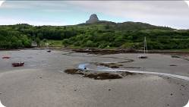

1. Look at this photo taken on the beach of the Isle of Eigg. What do you notice? Look at the diagram below and explain this natural phenomenon.
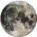
Moon
Earth
High Tide

Low Tide

This text can help you to describe why low tides and high tides are caused.
Put in these phrases:

bulge – gravitiy – high – low – moon – opposite – pulls – water levels

As the _____________ travels around the earth it attracts the sea and _____________ it upwards so that the sea level is always changing. This is because the _____________ of the moon pulls the sea a little bit more than the earth. This makes the water _____________ in the direction of the moon. There is another bulge on the _____________ side as the earth is pulled toward the moon at the same time. In the bulge the _____________ rise, and this is called _____________ tide. It takes about 12 hours and 25 minutes between the two high tides. _____________ tides happen between each high tide.
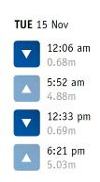
2a. Describe the process of the tides on the Isle of Eigg on November 15.
These words and expressions may help you:

sea level rises/falls – high/low tide is reached

_____________________________ _____________________________
© NASA (2); SWR (1)
_____________________________ _____________________________

2b. Imagine you lived on the Isle of Eigg.
What would the regular change of the tides mean for you in your everyday life?

