Watching the film

While watching the film take down notes on what you see and hear.

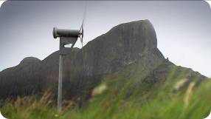
The Island of Eigg is situated __________________.
About ________________ live here today. In __________ the islanders ___________________.
Eigg has produced its own ________________ since _________________.
Today they use _________________ and they have to repair their ____________________ on their own.
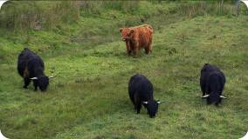
Farmer Anne Smith on the Isle of Mor has _________________ . She keeps _________________ cattle that are very robust animals. Her main source of income, however, are her _________________.
The wool is processed right on _________________.
The two women produce _________________ that are worn by _________________.
There are special patterns for each _________________.
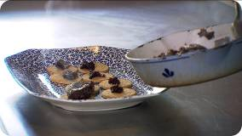

Haggis is an old Scottish _________________.
It is made from _________________ that is mixed with oats.
Haggis is eaten with _________________.

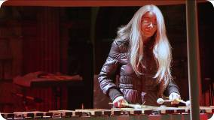
The capital of Scotland is _________________. In _________________ the Scottish formed their own parliament _________________. The Edinburgh International Festival features both amateur and _________________ . Evelyn Glennie is _________________ who lost nearly her complete hearing when _________________. She feels music _________________ and she can _________________.
The animotion show is a mix of _________________.

