Watching the film

While watching the film take down notes on what you see and hear.
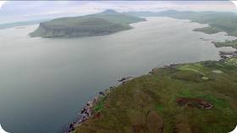

Scotland has coast on _______________ sides:
___________________ mountains and almost ___________________ islands.

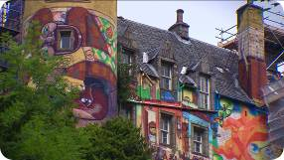

Kelburn Castle lies on _________________
The Boyle family has lived here ____________________
To pay for the upkeep of the castle, David and his father organize _______________________

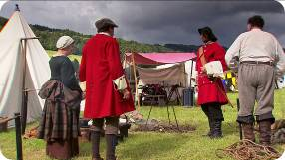

The Scottish Highlands are ___________________ high.
Near Killiecrankie the Scots act out ________________________________

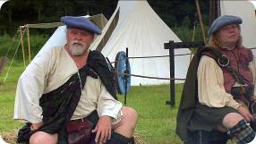
Scotland and England were rivals _________________
In 1603 the English had no king for their throne, so the Scottish ________________________
85 years later the English parliament replaced the Catholic King James II with the Protestant __________
The Catholic highlanders rebelled against __________ and fought a battle against ______________________
In 1707 England and Scotland were united and ______________________

