Writing task: A picture story (Jack)

Imagine you are Jack and you want to tell people your story. Look at the pictures and use the words to write a story. Start like this:

My name is Jack and I have experienced racism. As a child I…
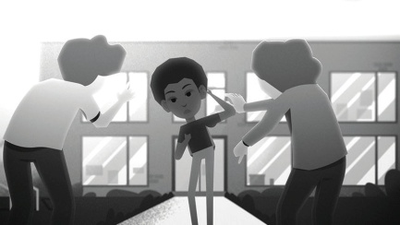
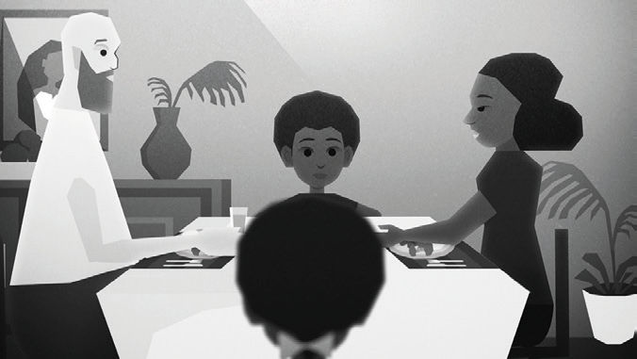

spent much time with mum – family
………………………………………………………

………………………………………………………
leave primary school – bullied
………………………………………………………

………………………………………………………
teacher – put non-white people at a table
………………………………………………………

………………………………………………………
secondary school – wrote a note
………………………………………………………

………………………………………………………
party – best friend - leave
………………………………………………………

………………………………………………………
tried to kick – tried to spit on
………………………………………………………

………………………………………………………
depression – suicidal thoughts
………………………………………………………

………………………………………………………
can like myself – reject racism
………………………………………………………

………………………………………………………

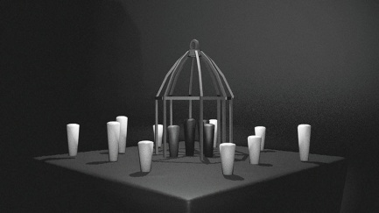
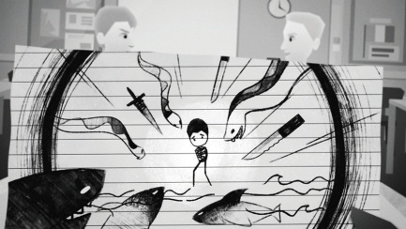

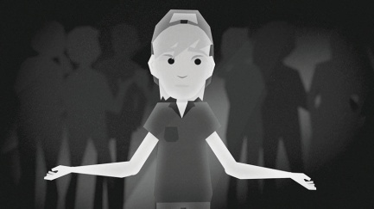
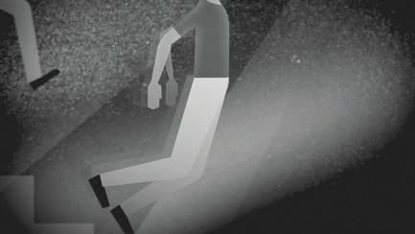

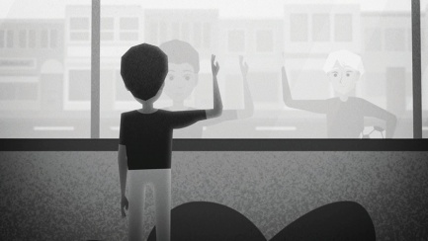
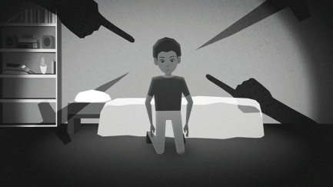

© SWR

