Colour of my skin – while viewing (Celine)


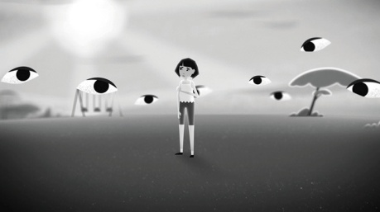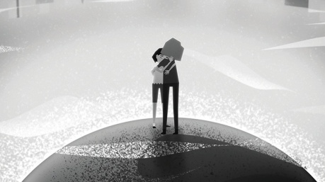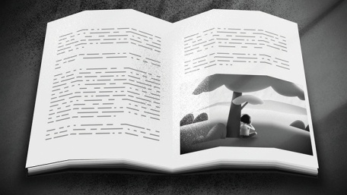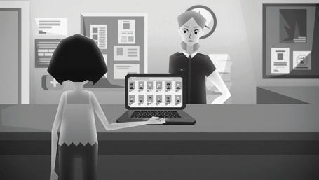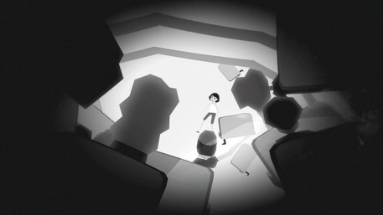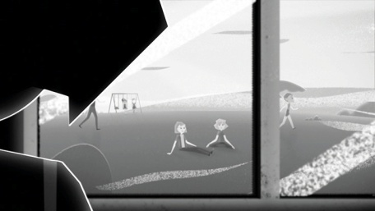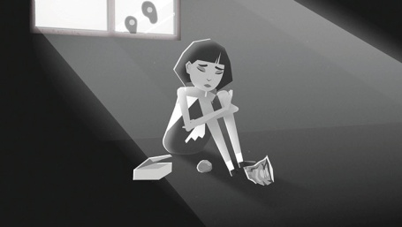Watch the clip and match the sentences with the pictures.

My childhood was quite normal.
I played with kids, read books and listened to music.

There was a song on the playground and kids pulled the fox eye. I felt really uncomfortable.
Kids threw empty crisp packets and chip boxes. They tried to throw a rock at our window and tried to egg our house.
I contacted the police and listed all the things they have done. They dropped the case.
We were just talking about how crazy this world is and how messed up racism is.
I decided to tell them to shut up. Everything was a whole mess. Lots of people were standing up for me.
I never went out and did all the things my classmates would do.

