Colour of my skin – while viewing (Shazmeen)

Watch the clip and put the pictures and statements in the correct order.
Write down the numbers 1-7.

 | A girl said: ‘Do you think if I wore this much fake tan, would I look like a Paki?’ | 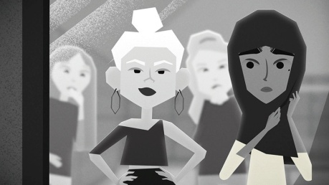
 | At school teachers hadn’t really done anything about it. I didn’t feel like I had anyone to talk to. | 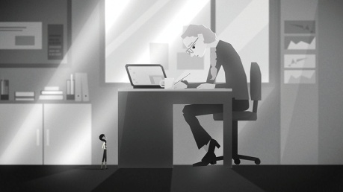
 | I started wearing a headscarf at school. I wanted to be closer to my faith. | 
 | A friend of mine came up to me and told me she can’t play with me. Her mum told her she can’t play with Pakis. | 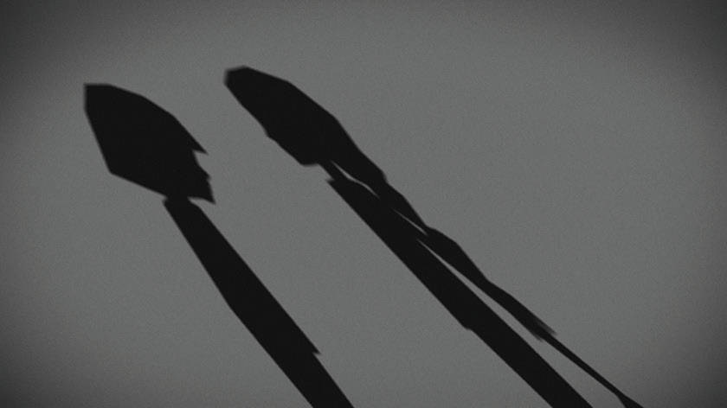
 | I started blogging and writing. | 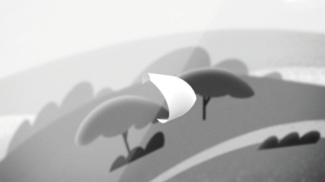
 | We watched a documentary about 9/11. A boy next to me said: ‘9/11 happened because of people like you!’ | 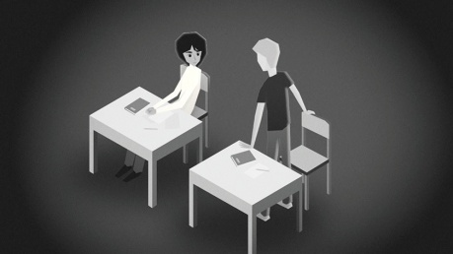
 | A teacher would leave his classroom door unlocked, so I could use it if I was upset. | 