Colour of my skin – while viewing (all films)

Watch the clip and tick the correct answer.

Name |  Celine  Shazmeen  Tapiwa  Tyrek  Ami  Jack  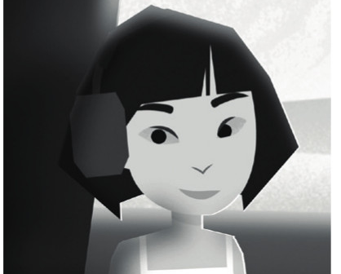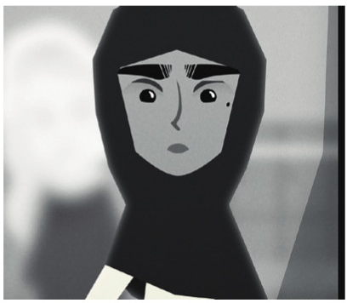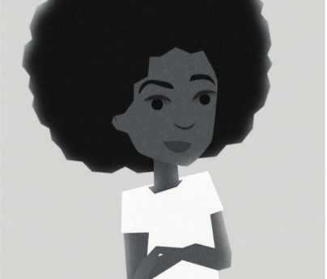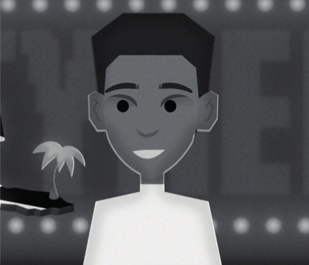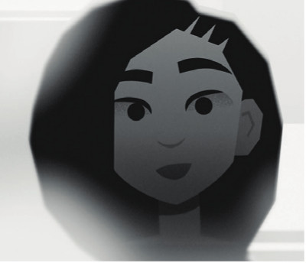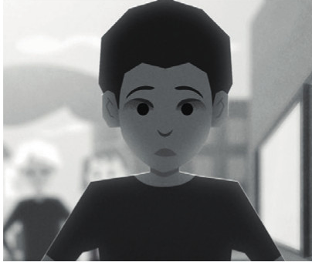
Family |  mum and four sisters   grew up in a single-parent household with her white dad   parents and grandparents from immigrant backgrounds   close with mum, parents loved each other   has a mum, sisters and brothers and a grandma, had a childminder   no information
Experiences with racism |  people touched her hair without asking   was called ‘Paki’ and accused of 9/11   things were thrown at her and her house (crisps packets, rocks, eggs)   was called the ‘N’ word and someone tried to kick him down the stairs   was stopped and searched by the police and called ‘monkey’ by her teacher   his Facebook profile picture was used and horrible comments were added
Feelings |  suffered from depression, anxiety and had suicidal thoughts   felt humiliated by the police and had trust issues   felt really uncomfortable and never really went out   always had a choking feeling in her throat   was cautious and on guard when people came close to her hair   felt like an outsider a lot
Help and support |  Black women at the hair salon and peoples’ videos on the internet   blogging / writing poetry   friends, family and school  © SWR   family and close friends   no information

