Arbeitsblatt 1: DNA-Evidence

1a. The human cell.
Read the text and label the picture of the cell

If you take a look at a human cell under a microscope you can see different cell organelles. They all lie in a liquid called cell plasma and they all have different functions. The control center of the cell is located in the so-called nucleus. This is also where our DNA or genetic material is stored. It contains information about e.g. our eye colour or the length of our arms and legs. It unmistakably identifies everyone of us. Other cell organelles are for example the mitochondria which are the powerhouses of the cell. The endoplasmic reticulum plays an important role for different metabolic processes. Part of it is covered with ribosomes which are responsible for the construction of proteins.

endoplasmatic

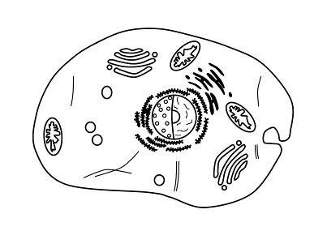
reticulum

ribosomes

nucleus containing the

the DNA / genetic

material
mitochondria

cell plasma

1b. Leaving traces behind.
Decide whether the following statements are right () or wrong (). Correct wrong statements in the text.

1. Fingerprints work like an identity card for each person, the pattern is unique.
2. Not even identical twins have the same fingerprint patterns.
3. If a criminal removes the physical fingerprints from a crime scene, it guarantees that he or she will not get caught.
© Martina Frietsch
4. Sometimes criminals leave their “biological visiting card” behind, without noticing.
5. There is a genetic defect called “Adermatoglyphia“ that causes a person to have no fingerprints.
6. DNA traces can be helpful to identify the exact age of a person.

Arbeitsblatt 2: The Genetic Code

2a. How is our genotype constructed?

Match the sentences with the correct numbers in the graphic. Start copying the sentences after that.

a. The cells develop different functions.
This is how e.g. organs, the blood system or body features evolve. Nr. _5_
b. In the end a human being is formed and keeps on growing and developing. Nr. 6
c. The other 23 chromosomes come from one of our father´s sperm cells. Nr. 2
d. When these two meet, the chromosomes combine to a full set of 46 chromosomes. Nr. 3
e. We get 23 chromosomes from our mother, stored in the egg cells. Nr. 1
f. After that, the cell divides. This leads to growth. Nr. 4

2b. Our DNA / genetic material.

Each of our chromosomes consists of a twisted rope ladder known as DNA. The side pieces are constructed out of sugar and phosphate . The rungs are made up of pairs of two bases. Either adenine and thymine or cytosine and guanine.

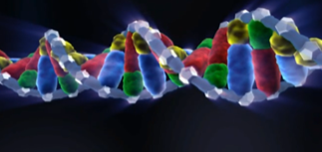

phosphate
adenine
sugar
thymine

cytosine
guanine

2c. Genotype portions.

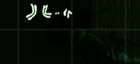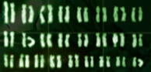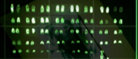
animal: goldfish

number of chromosomes: 50

animal: dog

number of chromosomes: 78

animal: fly
© SWR

number of chromosomes: 8

Arbeitsblatt 3: The Paternity Test

3a. Collecting evidence for the test.

Items that are very likely to contain a large number of genetic material of the potential father:
- cigarette butts he smoked
- the comb he uses in the morning
- a glas he drank from
- one of his plasters, found on the bathroom floor
- his used tissue from the bin

3b. Is he the father or not?

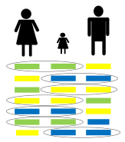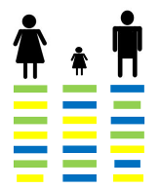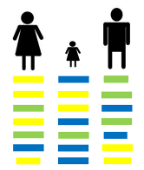

father (  ) father ( x ) father ( x )

Arbeitsblatt 4: Determining the Genetic Fingerprint in the Laboratory

4. DNA replication. Match the pictures with the correct texts. Fill in the letters. Then cut out the texts and glue them next to the pictures.

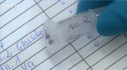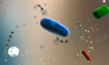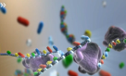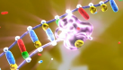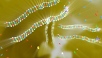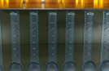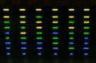
After that, the tools for constructing the ladders are given to the sample: Primers, that define the start of copying and enzymes that turn single strands into double strands.

Crime lab analysis focuses on parts of the DNA whose length differs from person to person.

A process called chromatography is used to divide the segments according to length.

Therefore first of all the building blocks for new DNA ladders are added: sugar, phosphate and the 4 bases.

In the lab the sample is given an identity number. After that the DNA has to be replicated millions of times over.

In the final stage the trace, along with other traces, is portrayed on a colour chart.

After 3 cycles of heating up, separation and duplication 8 copies are created, after 30 cycles, the total is 1 billion.

Different temperatures cause the DNA strands to separate and the primers to dock on. This is where the enzyme polymerase starts to turn each individual strand into a double strand.

A
B
C
E
F
G
H
D
A
D
E
F
H
B
C
G

© SWR

