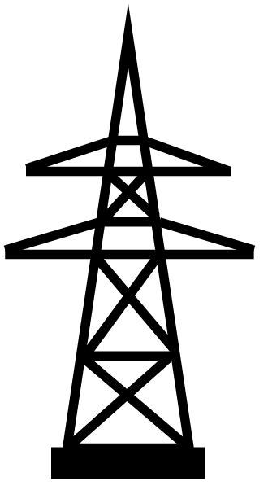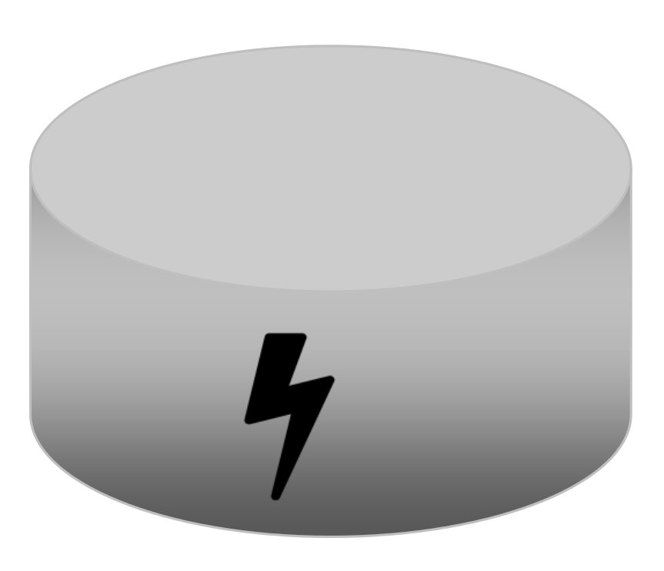
Energiespeicher und Stromnetze – Transfer

Nimm Stellung zu den folgenden Karikaturen und beschreibe mithilfe des Bildes unten die deutsche Energieversorgung der Zukunft.

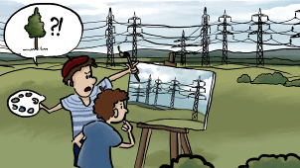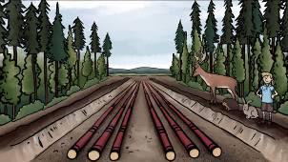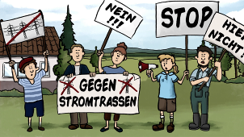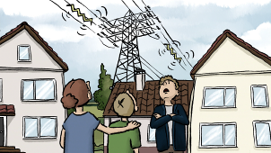
© SWR
______________________________________________________________________________________

______________________________________________________________________________________

______________________________________________________________________________________

______________________________________________________________________________________

















