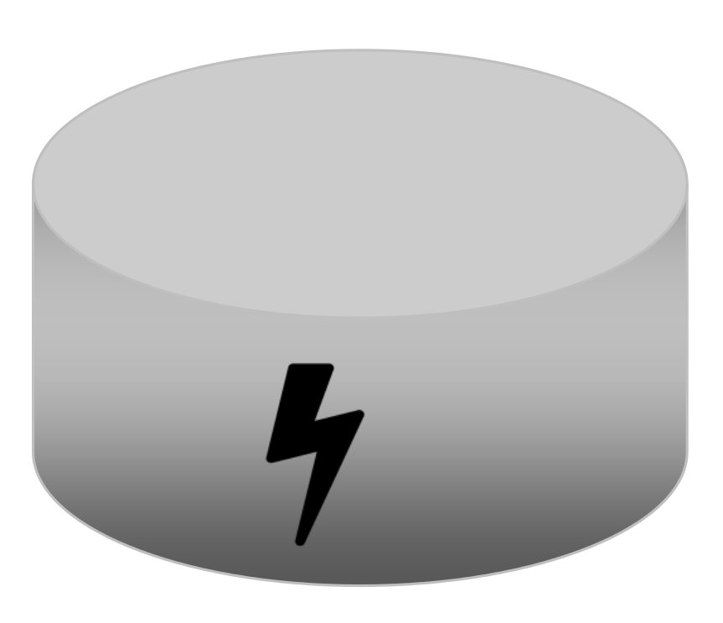

Energiespeicherverfahren

Experte 3: Elektroauto

______________________________________________________________________________________
______________________________________________________________________________________
______________________________________________________________________________________

Vorteile | Nachteile

Experte 4: Energiepark Mainz „Power-to-Gas“

______________________________________________________________________________________
______________________________________________________________________________________
______________________________________________________________________________________

Vorteile | Nachteile

Experte 5: „Power-to-Heat“

______________________________________________________________________________________
______________________________________________________________________________________
______________________________________________________________________________________

Vorteile | Nachteile

