Melbourne – Facts

Quick facts about Melbourne
 | Greater  Melbourne | Greater Sydney | Greater  New York City | Greater London | Berlin  (Metropolitan region)
metropolitan area ( km²) | 9,990.5 | 1,664 | 1,214 | 1,572 | 891.68
population | 4,529,500 | 4,627,345 | 20,182,305 | 8,546,761 | 4,469,439
resident  population | 128,963  city centre | 205,339  city centre | 1,600,000  Manhattan | 6,307  City of London | 1,183,100  city centre
population by day | 854,000  city centre | 610,000  city centre | 3,100,000  Manhattan | 358,266  City of London | 1,369,000  city centre

The Melbourne metropolitan area covers ... km². Sydney’s area is much smaller / ... times smaller than ...

1 a. Compare the metropolitan area of Melbourne to those of the other cities displayed in the table.
Melbourne, Sydney and ... have about the ... number of people / inhabitants. Greater New York City is ... times as big as ...
1 b. How many people live in those five cities?

1 c. Compare the cities’ resident population to the population by day. Explain the differences and their effects.
In Melbourne’s inner city there are just about ... who live there. During the day the number of people rises to as many as .../ During the day ... people use the city ... This means that ...

Where does the majority of people live? Why?

Melbourne is the world’s most liveable city for the sixth year running!

Rank | City | Country
1 | Melbourne | Australia
2 | Vienna | Austria
3 | Vancouver | Canada
4 | Toronto | Canada
5 | Calgary | Canada
6 | Adelaide | Australia
7 | Perth | Australia
8 | Auckland | New Zealand
9 | Helsinki | Finland
10 | Hamburg | Germany
source: The Economist

2. Every year the British newspaper THE ECONOMIST (August 18 2016) publishes a list of the world’s most and least liveable cities – that is, which locations around the world provide the best or the worst living conditions. In 2016 Melbourne topped the list for the sixth time in a row. The so called liveability index is based on data about stability, infrastructure, education, health care and environment.

2a. Find the top ten cities on a world map and comment on them. How do you feel about these most liveable cities in the world?

2b. What is most important for you? Do you live in a city or in the country or would you rather like to live in a city or in the country?

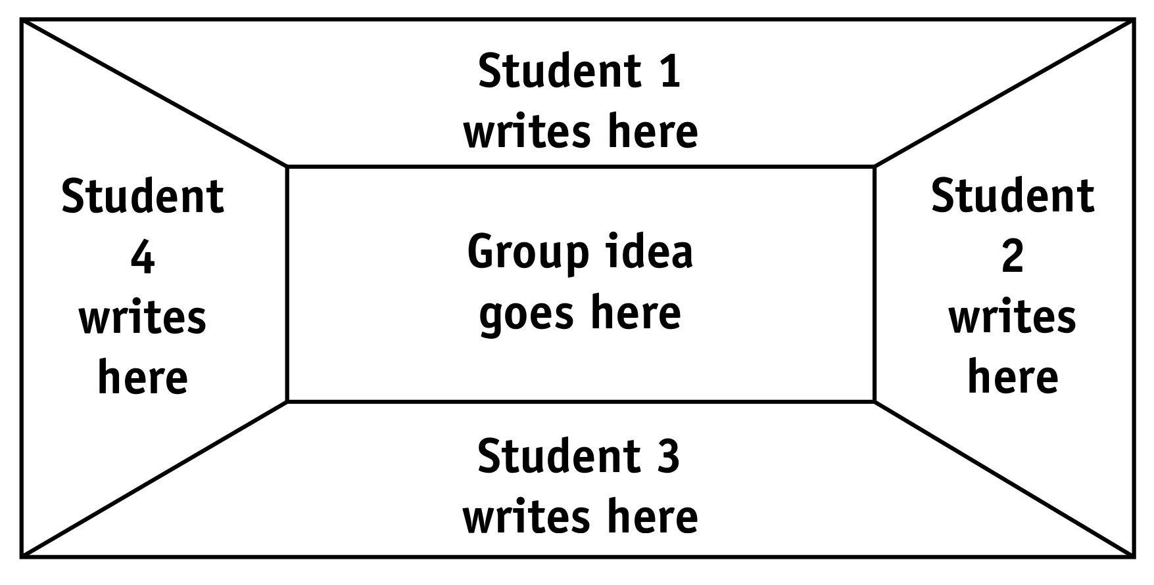Form groups of up to four members and draw a placemat for your group. Everybody thinks about the topic of living in a big city or in the country and writes three or four ideas in one part of the placemat. After that share your ideas with your partners and agree on five things that everybody in your group thinks are most important. Write them in the centre of your placemat. Tell the class about your group’s ideas. Discuss!

