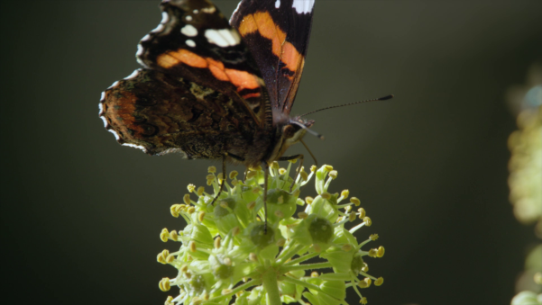
Der Schmetterling

1. Was macht der Schmetterling „Admiral“, bevor der Winter kommt?

______________________________________________________________
______________________________________________________________________________
______________________________________________________________________________
______________________________________________________________________________

2. Was erfahrt ihr im Film über den Frostspanner?

______________________________________________________________________________
______________________________________________________________________________
______________________________________________________________________________
______________________________________________________________________________
______________________________________________________________________________
______________________________________________________________________________
______________________________________________________________________________

3. Was machen die Frostspanner und die Admirale im Frühling?

______________________________________________________________________________
______________________________________________________________________________
______________________________________________________________________________
______________________________________________________________________________
4. Schmetterlinge sind gefährdet. Warum? Recherchiert im Internet.

______________________________________________________________________________
______________________________________________________________________________
______________________________________________________________________________
______________________________________________________________________________

5. Was könnt ihr tun, um Schmetterlinge zu schützen? Recherchiert im Internet.

______________________________________________________________________________
______________________________________________________________________________
______________________________________________________________________________
______________________________________________________________________________
______________________________________________________________________________
______________________________________________________________________________

