Die Ausbildung zum Ritter

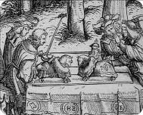
________________________________________________________

________________________________________________________

________________________________________________________

________________________________________________________

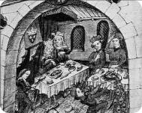
________________________________________________________

________________________________________________________

________________________________________________________

________________________________________________________

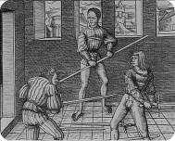
________________________________________________________

________________________________________________________

________________________________________________________

________________________________________________________

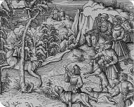
________________________________________________________

________________________________________________________

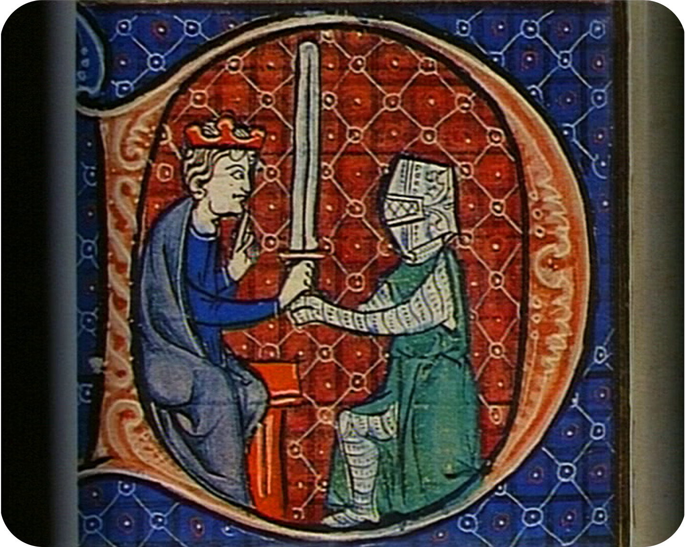________________________________________________________

________________________________________________________

________________________________________________________

________________________________________________________

________________________________________________________

________________________________________________________

© SWR (4)
Sichte den Filmausschnitt und notiere die wesentlichen Informationen. Die Bilder sind dem jeweiligen Filmausschnitt entnommen. Sie helfen dir, dich leichter an Filmdetails zu erinnern. Besprich, kontrolliere, ergänze mit den Arbeitspartnern des „gleichen Themas“ deine Ergebnisse.

